Software Requirements Specification

BTJ

VitalIQ — BTJ Fitness Tracker
https://github.com/Callmejarod/VitalIQ-AI-Health-App
Team BTJ · Brandon Galli · Jarod Atienzo · Thaigo Amaro Da Silva

Table of Contents
BTJ 1
Table of Contents 2
System Scope & Architectural Intent 4
System Purpose and Vision 4
Functional Scope 4
Architectural Intent 6
Platform Assumptions 10
Target Platform 10
Hardware Assumptions 10
Development Environment 11
Compliance and Privacy Assumptions 11
Testing Assumptions 12
Functional Requirements List 12
1. User Account & Profile Management 12
2. Sensor-Based Workout Tracking 12
3. Workout & Activity Logging 13
4. Health & Lifestyle Logging 14
5. AI Insights & Health Intelligence 15
6. Reactive UI & State Management 15
7. Navigation & Screen Management 16
8. Persistence & Repository Architecture 17
9. Asynchronous Processing 17
10. Data Visualization & Analytics 18
11. System Constraints & Compliance 18
User Stories 19
Epic: Workout Tracking 19
User Story 1 — Start Workout Session 19
Epic: Health Logging 20
User Story 2 — Log Blood Pressure 20
Epic: AI Insights 20
User Story 3 — Generate AI Health Insights 20
Epic: Profile Management 21
User Story 4 — Create User Profile 21
Use Cases 22
Workout Tracking Use Cases 22
Use Case 1 — Start Workout Session 22
Health Logging Use Cases 23
Use Case 2 — Log Blood Pressure Reading 23
AI Insights Use Cases 24
Use Case 3 — Generate AI Health Insights 24
Profile Management Use Cases 25
Use Case 4 — Create User Profile 25
Use Case Diagrams 27
Diagram 1 - Workout Tracking 27
Diagram 2 - Blood Pressure Logging 28
Diagram 3 - AI Health Insights 29
Diagram 4 - User Profile Management 30
Acceptance Criteria 30
User Story 1 — Start Workout Session 30
User Story 2 — Log Blood Pressure 31
User Story 3 — Generate AI Health Insights 31
User Story 4 — Create User Profile 31
Traceability Matrix 32
Operational Flow 33
1.1 User Profile Creation Flow 33
1.2 Active Workout Tracking Flow (Sensor-Driven Flow) 34
1.3 Workout Session Completion Flow 35
1.4 Health Data Logging Flow (Manual Entry) 35
1.5 AI Health Insights Generation Flow 35
11.6 App Resume / Data Recovery Flow 36
Activity Diagram 1: Sensor-Driven Workout Tracking 37
Activity Diagram 2: AI Insights Generation 38
Activity Diagram 3: Manual Health Data Logging 39
Sequence Diagrams 40
State Machine Diagram 45
Main Behavioral Core Reasoning: 46

System & Core Architecture Design

VitalIQ — BTJ Fitness Tracker
Team BTJ · Brandon Galli · Jarod Atienzo · Thaigo Amaro Da Silva

System Scope & Architectural Intent
VitalIQ is a native Android application designed to serve as a comprehensive personal health and fitness intelligence platform. The system integrates hardware sensor data, manual biometric logging, and AI-powered analysis to provide users with a holistic, data-driven picture of their health. This document section defines the intended scope of the system and the architectural decisions that will guide its development throughout the project lifecycle.

System Purpose and Vision
VitalIQ addresses the gap between passive fitness tracking and actionable health intelligence. While many fitness applications record raw data, VitalIQ is designed to interpret that data and translate it into personalized, ranked health recommendations. The system accomplishes this by combining real-time sensor acquisition, structured local persistence, and an external AI inference API into a unified user experience.

Functional Scope
The following functional areas define the boundaries of the VitalIQ system for this project iteration:
- Sensor-Based Activity Tracking
- Real-time workout tracking using the device accelerometer and step counter via Android SensorManager.
- Automatic activity classification into four states: walking, running, stationary, and general movement.
- Live display of step count, session duration, movement intensity, and estimated calorie burn during active workout sessions.

- Manual Biometric and Lifestyle Logging
- User input for blood pressure, resting heart rate, body weight, body composition, and sleep duration.
- Medication adherence logging and nutritional intake tracking including water consumption.
- Health record import in JSON and CSV formats to consolidate pre-existing user data into the local store.

- AI-Powered Health Insights
- Aggregation of all stored sensor data, manual entries, and historical trends into a structured payload.
- Transmission of that payload to an external AI model API (external API integration).
- Display of a holistic health score, category-level breakdowns (cardiovascular, activity, nutrition, hydration, medication adherence, recovery), and ranked improvement suggestions.

- Data Visualization and History
- Graphical visualization of tracked metrics over time: step trends, weight trend, blood pressure trend, activity classification breakdown.
- Full workout session history including activity type, duration, intensity, and calories burned.

- User Profile Management
- User profile creation capturing age, height, weight, and personal fitness goals.
- Profile data is used to personalize calorie estimation and AI insight generation.

Out-of-Scope Items
The following features are explicitly excluded from the current project scope to maintain MVP focus:
Excluded Feature | Rationale
Wearable / Smartwatch Integration | Requires additional Bluetooth APIs and hardware pairing logic beyond the defined sensor scope.
Social Features / Messaging | Introduces network-layer complexity, authentication, and privacy concerns unrelated to health tracking.
Cloud Sync / Remote Storage | All persistence is local via Room database. Cloud sync is a future enhancement.
Medical Diagnosis or Clinical Advice | VitalIQ provides wellness insights only. No diagnostic or clinical claims are made.

Architectural Intent
VitalIQ follows a strict layered MVVM (Model-View-ViewModel) architecture. Each layer depends exclusively on the layer directly below it, no layer is permitted to bypass another. This constraint is enforced throughout all application code and is aligned with the team's Repository + Room architecture plan.
Layered Architecture Overview
The full responsibility flow across all architectural layers is defined as follows:

Layer | Technology | Responsibility
UI | Jetpack Compose | Observes StateFlow from ViewModel. No references to Repository, DAO, or database. No coroutine launches.
ViewModel | viewModelScope + StateFlow | Owns UI state and lifecycle scope. Launches all coroutines. Calls Repository only, never DAO directly.
Repository | Plain Kotlin classes | Sole authority over persistence decisions. Arbitrates between Room, Calorie API, and AI Insights API. Constructs AI payload.
DAO | Room @Dao interfaces | Exposes suspend functions and Flow queries for all DB operations. Implementations generated by Room at compile time.
Room Database | VitallQDatabase (RoomDatabase) | Mediates all SQLite access. Verifies queries at compile time. Generates DAO implementations.
SQLite | On-device storage engine | Physical persistence layer. Fully managed by Room. Invisible to all layers above DAO.

ViewModel Ownership
Each primary screen domain owns a dedicated ViewModel that serves as the single source of truth for its UI state. ViewModels interact exclusively with the Repository through its public API; they have no knowledge of any DAO interface, Room types, or whether data originates from local storage or an external API.
ViewModel | Owned State | Primary Trigger
WorkoutViewModel | Active session state, live step count, intensity, duration, activity classification | Sensor event callbacks via SensorManager
HealthLogViewModel | Manual entry forms, submission state, entry history list | User form input events
InsightsViewModel | AI health score, category scores, improvement suggestions, loading/error state | Repository AI API response
HistoryViewModel | Workout history list, chart data series, date range filter | Repository Flow emissions from Room
ProfileViewModel | User profile fields, import status, validation errors | User profile creation / update events

Coroutine Placement
All asynchronous operations are managed through structured concurrency using Kotlin coroutines scoped to viewModelScope:
• Dispatchers.Default — sensor computation, activity classification logic, calorie estimation algorithms.
• Dispatchers.IO — all Room database reads and writes, AI API network requests, file import parsing.
• No GlobalScope usage, no runBlocking calls, no main-thread blocking operations are permitted.
• Coroutine scope management belongs exclusively to the ViewModel. The UI layer does not launch coroutines for data operations.

Persistence Intent
All data persistence is handled locally via the Room database (VitalIQDatabase) through the Repository layer. No Activity, Composable, or ViewModel accesses any DAO directly. The Repository is the sole owner of all persistence decisions.
Entity | DAO | Data Source | Key Persisted Fields | Flow
User | UserDao | Profile Setup screen | Age, height, weight, fitness goal | Yes
WorkoutSession | WorkoutSessionDao | Sensor streams + ViewModel aggregation | Activity title, duration, intensity, steps, calories, timestamp | Yes
ActivityLog | ActivityLogDao | Sensor derived events + manual import | Classification type, step count snapshot, session ID, timestamp | Yes

DAO Operations Summary
Each DAO exposes a focused, minimal set of operations. All write operations are suspend functions; all query operations return Flow for reactive UI updates:
DAO | Operation | Return Type
UserDao | insertUser(user: User) | Long (suspend)
UserDao | getUser() | Flow<User?>
WorkoutSessionDao | insertWorkoutSession(session: WorkoutSession) | Long (suspend)
WorkoutSessionDao | deleteWorkoutSession(session: WorkoutSession) | Unit (suspend)
WorkoutSessionDao | getAllSessions() | Flow<List<WorkoutSession>>
WorkoutSessionDao | getSessionById(id: Int) | WorkoutSession? (suspend)
ActivityLogDao | insertActivityLog(log: ActivityLog) | Long (suspend)
ActivityLogDao | getLogsForSession(sessionId: Int) | Flow<List<ActivityLog>>
ActivityLogDao | getLogsByDateRange(start: Long, end: Long) | List<ActivityLog> (suspend)

Reactive State
UI state is exposed from ViewModels as StateFlow. Jetpack Compose UI observes StateFlow via collectAsState(), triggering automatic recomposition when state changes. Sensor updates flow unidirectionally: SensorManager -> ViewModel processing -> StateFlow emission -> UI recomposition. This unidirectional data flow prevents state inconsistencies and eliminates manual UI refresh logic.
Layer Boundary Rules
The following rules are enforced across all layers and are non-negotiable for architectural compliance:
• The UI layer holds no reference to any Repository, DAO, or VitalIQDatabase instance.
• The ViewModel has no knowledge of Room, SQLite, DAO interfaces, or Room-specific annotations (@Entity, @Dao, @Query).
• The ViewModel does not know whether data originates from Room, the Calorie API, or the AI Insights API.
• The Repository constructs the AI analysis payload — aggregating WorkoutSession, ActivityLog, and User data — before making the external API call. This logic does not belong in the ViewModel.
• Replacing Room with a different persistence technology, or swapping the AI API provider, requires zero changes to the ViewModel layer.

Platform Assumptions
The following assumptions define the target platform, development environment, and operational constraints for VitalIQ. These assumptions inform all architectural, sensor, and API decisions made throughout the project.

Target Platform
Parameter | Assumption
Operating System | Android (native)
Minimum SDK Version | Android 8.0 (API Level 26) ensures availability of all required sensor APIs, Room features, and Kotlin coroutines support.
Target SDK Version | Android 14 (API Level 34) targets the current stable Android release for full lifecycle and permission compatibility.
Screen Orientation | Portrait mode primary. Landscape not explicitly supported in MVP scope.
Form Factor | Smartphone. Tablets and foldables are not targeted in MVP scope.

Hardware Assumptions
Hardware Component | Assumption
Accelerometer | Present on all target devices including emulators. Required for activity classification. App will gracefully handle sensor unavailability with a user-facing error state.
Step Counter Sensor | Available on physical devices running Android 4.4+ (API 19). May not be available on all emulators. Emulator testing will fall back to accelerometer-derived step estimation.
Internet Connectivity | Required for AI Insights API calls. App remains fully functional offline with a graceful degraded state (insights unavailable message). All core tracking and logging functions offline.
Local Storage | Minimum 50 MB available for Room database and imported health records.

Development Environment
Component | Specification
IDE | Android Studio
Language | Kotlin
UI Framework | Jetpack Compose - declarative UI, no XML layouts.
Async Framework | Kotlin Coroutines + Flow / StateFlow
Local Database | Room Persistence Library (SQLite abstraction)
Navigation | Jetpack Navigation Component with a Structured NavGraph
Version Control | Git via GitHub repository. All team members contribute via feature branches with pull requests.
Project Management | GitHub Project Board for task scheduling and delegation.
Build System | Gradle with Kotlin DSL (build.gradle.kts)

Compliance and Privacy Assumptions
• VitalIQ does not transmit personally identifiable information (PII) to any external server except as included in the AI insights payload (aggregated health metrics only, no name/email/location).
• The application does not claim to provide medical diagnoses or clinical health advice. All AI-generated content is framed as wellness guidance.
• Health data is stored exclusively on the user's local device via Room. No cloud backup or remote sync is implemented in this iteration.
• The application will comply with Android runtime permission requirements for sensor access (ACTIVITY_RECOGNITION permission for step counter on Android 10+).

Testing Assumptions
• Primary testing is performed on Android Emulator (API 34) via Android Studio AVD Manager.
• Physical device testing is performed on team members' personal Android devices where available.
• Sensor simulation in the emulator will be used for accelerometer events. Step counter limitations on emulators are known and accepted.
• No automated UI testing (Espresso / Compose Test) is required for MVP; manual testing with documented test cases is sufficient for this iteration.

Functional Requirements List

1. User Account & Profile Management
FR-1: User Profile Creation
The system shall allow users to create and edit a personal health profile containing:
- Name
- Age
- Height
- Weight
- Fitness goals
FR-2: Profile Persistence
The system shall persist user profile information locally using Room Database.
FR-3: Health Record Import
The system shall allow users to import existing health records in JSON or CSV format.

2. Sensor-Based Workout Tracking
FR-4: Accelerometer Integration
The system shall access the device accelerometer using Android SensorManager.
FR-5: Step Counter Integration
The system shall access the device step counter sensor using Android SensorManager.
FR-6: Real-Time Activity Monitoring
The system shall continuously monitor sensor data during active workout sessions.
FR-7: Activity Classification
The system shall classify user movement into categories including:
- Walking
- Running
- Stationary
- General movement
FR-8: Live Step Tracking
The system shall display live step counts during workout sessions.
FR-9: Workout Session Timing
The system shall track workout session duration in real time.
FR-10: Workout State Management
The system shall allow users to:
- Start a workout session
- Pause a workout session
- End a workout session
FR-11: Sensor Data Filtering
The system shall apply filtering or threshold logic to reduce inaccurate sensor readings and noise.

3. Workout & Activity Logging
FR-12: Workout Session Storage
The system shall store completed workout sessions locally in Room Database.
FR-13: Workout History Retrieval
The system shall display a list of historical workout sessions.
FR-14: Activity Metrics Storage
The system shall persist activity-related metrics including:
- Step totals
- Activity classification
- Duration
- Intensity
- Estimated calories burned
FR-15: Historical Trend Tracking
The system shall maintain historical data for trend analysis over time.

4. Health & Lifestyle Logging
FR-16: Manual Health Logging
The system shall allow users to manually log biometric data including:
- Blood pressure
- Resting heart rate
- Weight
- Body composition
FR-17: Medication Tracking
The system shall allow users to log medications and medication adherence.
FR-18: Nutrition Logging
The system shall allow users to log food intake and nutrition information.
FR-19: Hydration Tracking
The system shall allow users to record daily water intake.
FR-20: Sleep Tracking
The system shall allow users to record sleep duration and sleep quality data.

5. AI Insights & Health Intelligence
FR-21: AI Payload Generation
The system shall compile sensor data, workout history, and manual health logs into a structured AI analysis payload.
FR-22: External AI API Integration
The system shall send health data to an external AI API for analysis.
FR-23: Health Score Generation
The system shall display an AI-generated overall health score.
FR-24: Category-Level Health Analysis
The system shall display AI-generated category scores for:
- Cardiovascular health
- Activity
- Nutrition
- Hydration
- Recovery
- Medication adherence
FR-25: Personalized Recommendations
The system shall display ranked actionable health and workout improvement suggestions generated by the AI system.

6. Reactive UI & State Management
FR-26: Reactive Dashboard Updates
The system shall automatically update UI components when sensor or health data changes.
FR-27: StateFlow Integration
The system shall expose application state using StateFlow from the ViewModel layer.
FR-28: Lifecycle-Safe State Management
The system shall preserve UI state during configuration changes using ViewModel architecture.
FR-29: Real-Time Workout Dashboard
The system shall display live workout metrics during active tracking sessions.

7. Navigation & Screen Management
FR-30: Navigation Graph Implementation
The system shall use Jetpack Navigation for screen transitions.
FR-31: Dashboard Screen
The system shall provide a dashboard screen displaying:
- Daily summaries
- Health score overview
- Quick actions
FR-32: Active Workout Screen
The system shall provide a live workout screen displaying:
- Current activity classification
- Step count
- Workout duration
- Intensity metrics
FR-33: Health Log Screen
The system shall provide a screen for manual health data entry.
FR-34: History & Analytics Screen
The system shall provide historical analytics and trend visualization screens.
FR-35: AI Insights Screen
The system shall provide a screen dedicated to AI-generated health insights and recommendations.
FR-36: Profile Setup Screen
The system shall provide a screen for user profile management and health record imports.

8. Persistence & Repository Architecture
FR-37: Repository Layer Separation
The system shall use a Repository layer to separate UI logic from persistence and API access.
FR-38: Room Database Persistence
The system shall persist all core application data using Room Database.
FR-39: Offline Data Availability
The system shall allow users to access previously stored workout and health data without internet connectivity.

9. Asynchronous Processing
FR-40: Coroutine-Based Processing
The system shall use Kotlin Coroutines for asynchronous execution.
FR-41: Background Database Operations
The system shall perform Room database operations using Dispatchers.IO.
FR-42: Background Sensor Processing
The system shall process sensor computations using Dispatchers.Default.
FR-43: Lifecycle-Aware Coroutine Scope
The system shall use viewModelScope for lifecycle-safe coroutine execution.
FR-44: Non-Blocking UI
The system shall ensure that sensor tracking, database operations, and API requests do not block the main thread.

10. Data Visualization & Analytics
FR-45: Historical Graph Visualization
The system shall display historical graphs for:
- Step counts
- Weight trends
- Blood pressure trends
- Workout activity trends
FR-46: Daily Summary Metrics
The system shall display daily aggregate fitness and health summaries.
FR-47: Activity Breakdown Visualization
The system shall visualize activity distributions across different workout classifications.

11. System Constraints & Compliance
FR-48: Local Data Persistence
The system shall maintain user data persistence across application restarts.
FR-49: Configuration Change Survival
The system shall preserve active UI state during device rotation and configuration changes.
FR-50: MVP Scope Enforcement
The system shall focus exclusively on:
- Sensor tracking
- Health logging
- AI-driven insights
and shall exclude:
- Smartwatch integration
- Social networking features
- User-to-user messaging systems.

User Stories

Epic: Workout Tracking

User Story 1 — Start Workout Session
As a fitness app user,
I want to start a workout tracking session,
So that the application can monitor my movement and activity in real time.
Acceptance Criteria
- User can press a “Start Workout” button.
- App begins collecting accelerometer and step counter data.
- Workout timer starts immediately.
- Current activity classification is displayed.
- Live step count updates in real time.
- Workout state persists during screen rotation.
Priority
High
Dependencies
- SensorManager integration
- ViewModel state management
- Coroutine sensor processing

Epic: Health Logging

User Story 2 — Log Blood Pressure
As a health-conscious user,
I want to manually record my blood pressure readings,
So that I can monitor trends in my cardiovascular health over time.
Acceptance Criteria
- User can input systolic and diastolic values.
- Entry includes timestamp/date.
- Data is stored in Room Database.
- Historical BP entries appear in analytics/history screen.
- Invalid inputs are rejected.
Priority
High
Dependencies
- Room entity for biometric logs
- Repository insertion methods
- Form validation logic

Epic: AI Insights

User Story 3 — Generate AI Health Insights
As a user,
I want AI-generated health recommendations,
So that I can improve my workouts and lifestyle habits using personalized guidance.
Acceptance Criteria
- App compiles workout and health log data.
- Structured payload is sent to AI API.
- API response includes:
  - overall health score
  - category scores
  - ranked recommendations
- Results display on AI Insights screen.
- API failures show an error message gracefully.
Priority
Medium
Dependencies
- API integration layer
- Repository networking functions
- AI response parser

Epic: Profile Management

User Story 4 — Create User Profile
As a first-time user,
I want to set up my personal profile,
So that the app can personalize health tracking and AI analysis.
Acceptance Criteria
- User can enter:
  - age
  - height
  - weight
  - fitness goals
- Profile data persists locally.
- Existing profile information can be edited later.
- Required fields must be validated.
Priority
High
Dependencies
- Room User entity
- Profile UI screen
- ViewModel state handling

Use Cases

Workout Tracking Use Cases

Use Case 1 — Start Workout Session
Use Case Name
Start Workout Session
Primary Actor
Fitness App User
Goal
Begin tracking workout activity in real time using device sensors.
Preconditions
- User has opened the application.
- Sensor permissions are granted.
- Sensors are available on the device.
Trigger
User presses the “Start Workout” button.
Main Success Scenario
- User taps the “Start Workout” button.
- App initializes workout session state.
- App activates accelerometer and step counter sensors.
- Workout timer begins running.
- App processes sensor data continuously.
- Current activity classification is displayed.
- Live step count updates on screen.
- Workout state persists during screen rotation.
- User continues workout tracking successfully.
Alternate Flows
- If sensor permissions are denied:
  - App displays permission request/error message.
- If sensor hardware is unavailable:
  - App informs the user that tracking cannot start.
Postconditions
- Workout session is active.
- Sensor data is actively being collected.
- UI reflects live workout metrics.

Health Logging Use Cases

Use Case 2 — Log Blood Pressure Reading
Use Case Name
Log Blood Pressure Reading
Primary Actor
Health-Conscious User
Goal
Record blood pressure readings for historical tracking and analysis.
Preconditions
- User is on the blood pressure logging screen.
- Database is initialized.
Trigger
User submits blood pressure values.
Main Success Scenario
- User enters systolic value.
- User enters diastolic value.
- User taps the “Save” button.
- App validates input values.
- App attaches current timestamp/date.
- App stores entry in Room Database.
- App refreshes history/analytics screen.
- New blood pressure record appears in history.
Alternate Flows
- If input fields are empty:
  - App displays validation errors.
- If values are invalid:
  - App rejects submission and requests correction.
Postconditions
- Blood pressure reading is stored successfully.
- Historical records are updated.

AI Insights Use Cases

Use Case 3 — Generate AI Health Insights
Use Case Name
Generate AI Health Insights
Primary Actor
Fitness App User
Goal
Receive personalized AI-generated recommendations based on health and workout data.
Preconditions
- User has existing workout or health log data.
- Internet connection is available.
Trigger
User opens or refreshes the AI Insights screen.
Main Success Scenario
- App gathers workout history and biometric logs.
- App formats data into structured API payload.
- App sends request to AI service.
- AI service processes user health data.
- API returns:
  - overall health score
  - category scores
  - ranked recommendations
- App parses response successfully.
- Insights are displayed on the AI Insights screen.
Alternate Flows
- If API request fails:
  - App displays an error message.
- If response parsing fails:
  - App displays fallback error state.
Postconditions
- AI recommendations are visible to the user.
- Insights data is available for review.

Profile Management Use Cases

Use Case 4 — Create User Profile
Use Case Name
Create User Profile
Primary Actor
First-Time User
Goal
Create a personalized profile for health tracking and AI recommendations.
Preconditions
- User opens the profile setup screen.
Trigger
User selects profile setup/create profile.
Main Success Scenario
- User enters age.
- User enters height.
- User enters weight.
- User selects fitness goals.
- User taps “Save Profile.”
- App validates required fields.
- App stores profile locally in Room Database.
- Profile information becomes available throughout the app.
Alternate Flows
- If required fields are missing:
  - App displays validation messages.
- If invalid data is entered:
  - App requests corrected input.
Postconditions
- User profile is stored locally.
- Profile can be edited later.

Use Case Diagrams

Diagram 1 - Workout Tracking
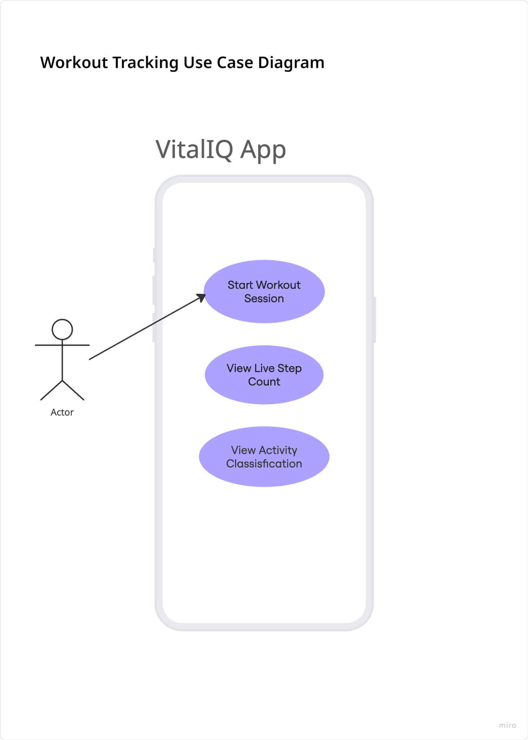

Diagram 2 - Blood Pressure Logging
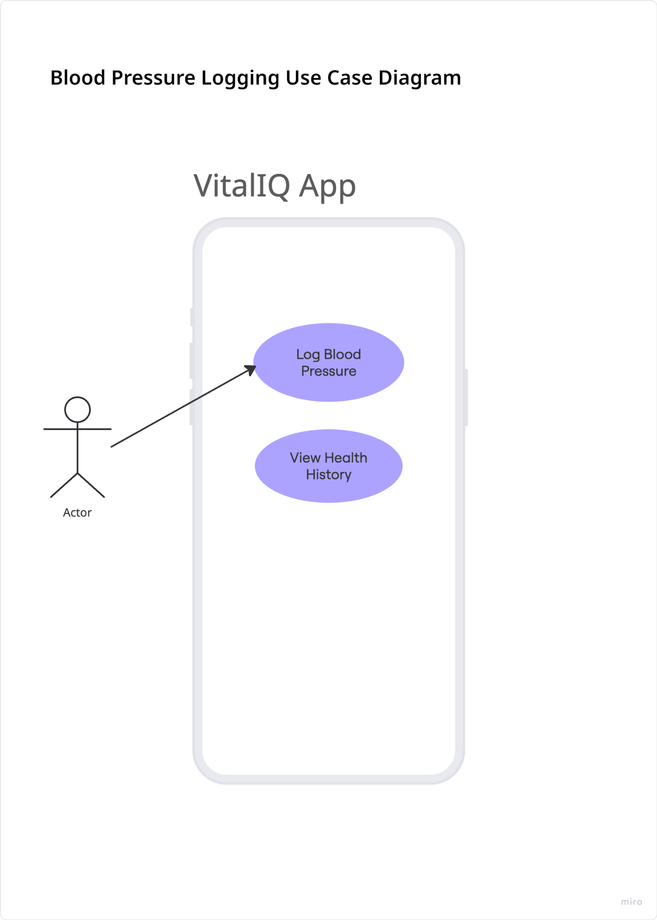

Diagram 3 - AI Health Insights
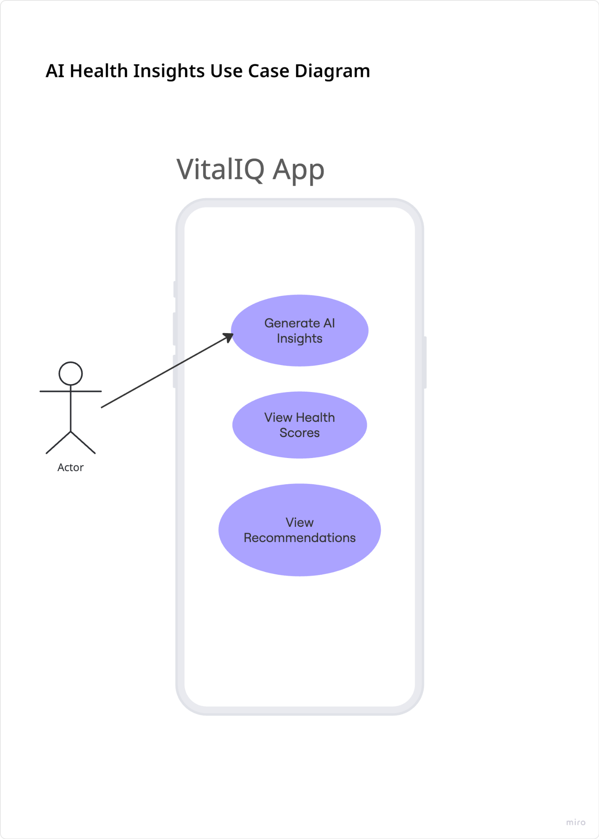

Diagram 4 - User Profile Management
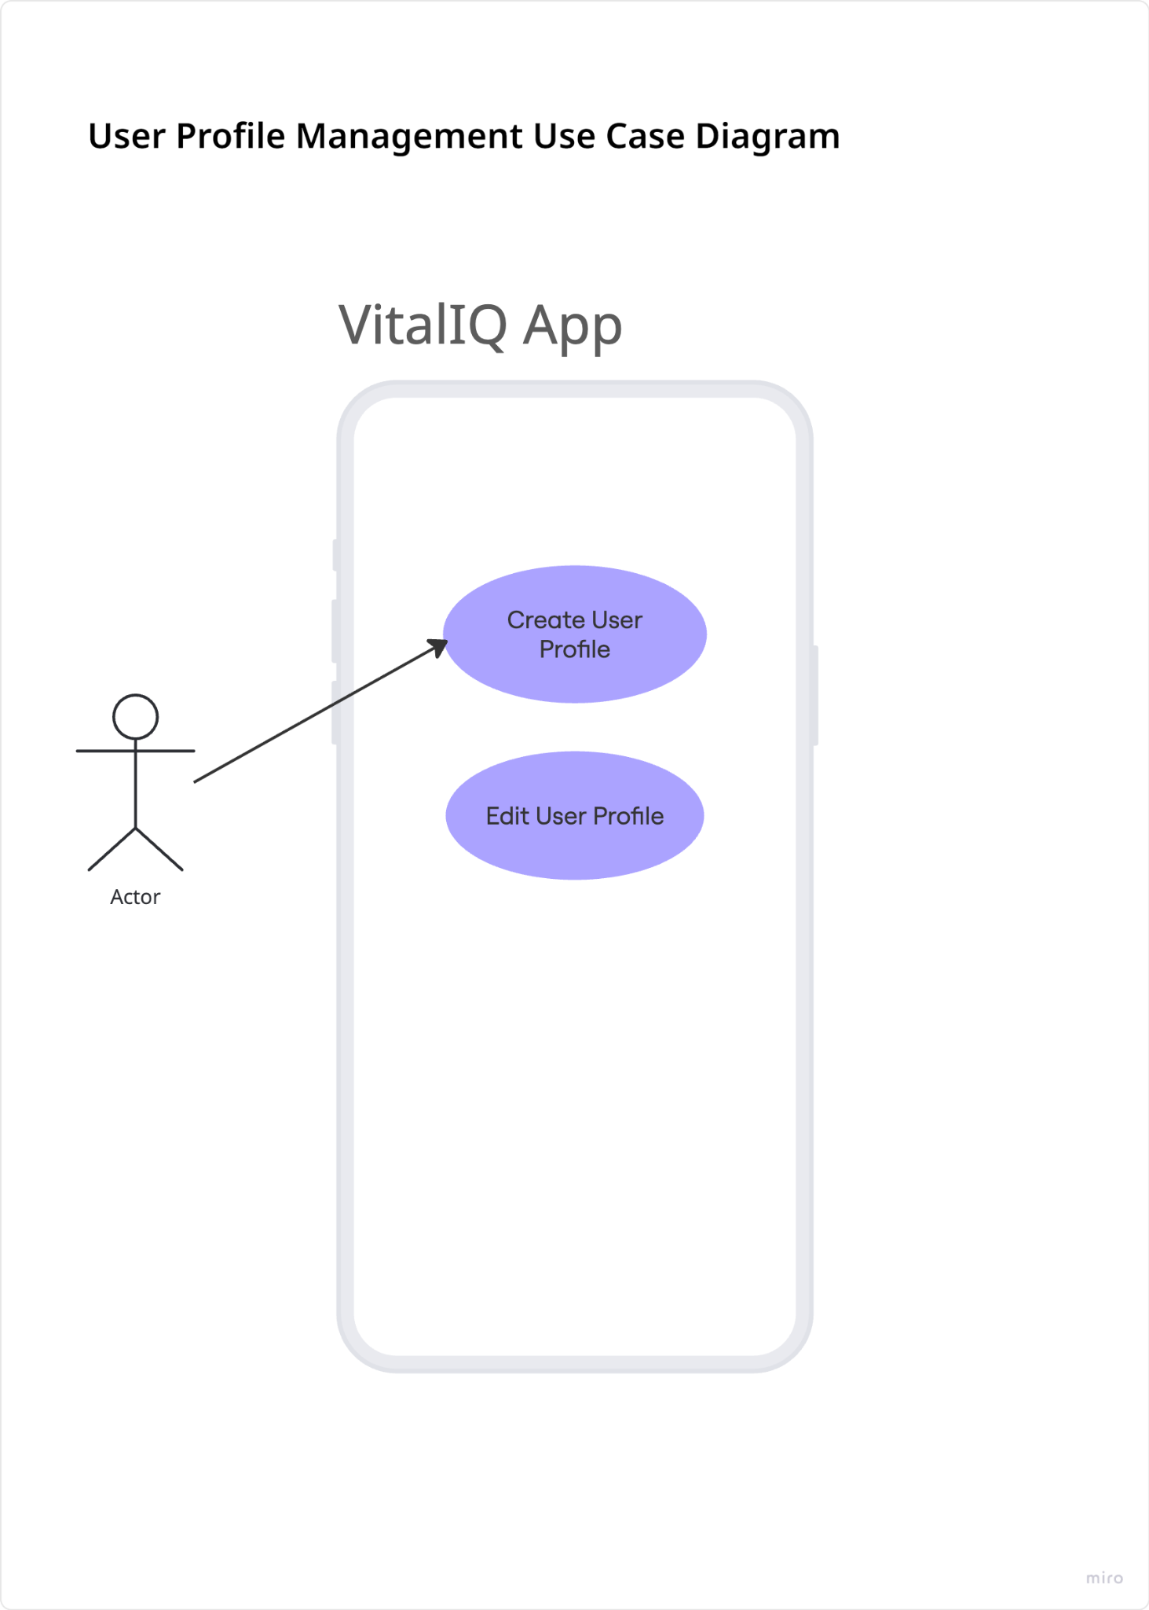

Acceptance Criteria

User Story 1 — Start Workout Session
Acceptance Criteria
- AC-1.1 User can press a “Start Workout” button.
- AC-1.2 Workout timer starts immediately after pressing start.
- AC-1.3 Accelerometer data begins collecting in real time.
- AC-1.4 Step counter updates continuously during the workout.
- AC-1.5 Current activity classification is displayed on screen.
- AC-1.6 Workout data updates reactively without manual refresh.
- AC-1.7 Workout session persists during screen rotation.
- AC-1.8 App handles unavailable sensors gracefully.

User Story 2 — Log Blood Pressure
Acceptance Criteria
- AC-2.1 User can enter systolic blood pressure value.
- AC-2.2 User can enter diastolic blood pressure value.
- AC-2.3 User can save the reading successfully.
- AC-2.4 Each entry stores the current date and timestamp.
- AC-2.5 Data is saved into the Room Database.
- AC-2.6 Historical blood pressure records display in the history screen.
- AC-2.7 Empty or invalid inputs are rejected.
- AC-2.8 Validation messages appear for incorrect values.

User Story 3 — Generate AI Health Insights
Acceptance Criteria
- AC-3.1 App gathers workout and health log data.
- AC-3.2 Structured data payload is sent to the AI API.
- AC-3.3 AI response includes an overall health score.
- AC-3.4 AI response includes category scores.
- AC-3.5 AI response includes ranked recommendations.
- AC-3.6 AI insights display correctly on screen.
- AC-3.7 Loading state appears while waiting for API response.
- AC-3.8 App handles API failures gracefully.
- AC-3.9 Error messages display when requests fail.

User Story 4 — Create User Profile
Acceptance Criteria
- AC-4.1 User can enter age.
- AC-4.2 User can enter height and weight.
- AC-4.3 User can select fitness goals.
- AC-4.4 Required fields are validated before saving.
- AC-4.5 Profile data persists locally after app restart.
- AC-4.6 Existing profile data can be edited later.
- AC-4.7 Invalid or empty fields display validation errors.
- AC-4.8 Saved profile data loads automatically when reopening the app.

Traceability Matrix

User Story ID | User Story | Acceptance Criteria ID | Acceptance Criteria
US-1 | Start Workout Session | AC-1.1 | User can press a “Start Workout” button.
US-1 | Start Workout Session | AC-1.2 | Workout timer starts immediately.
US-1 | Start Workout Session | AC-1.3 | Accelerometer data begins collecting in real time.
US-1 | Start Workout Session | AC-1.4 | Step counter updates continuously during workout.
US-1 | Start Workout Session | AC-1.5 | Current activity classification is displayed.
US-1 | Start Workout Session | AC-1.6 | Workout state persists during screen rotation.
US-2 | Log Blood Pressure | AC-2.1 | User can enter systolic blood pressure value.
US-2 | Log Blood Pressure | AC-2.2 | User can enter diastolic blood pressure value.
US-2 | Log Blood Pressure | AC-2.3 | Entry includes timestamp/date.
US-2 | Log Blood Pressure | AC-2.4 | Data is stored in Room Database.
US-2 | Log Blood Pressure | AC-2.5 | Historical records display in history screen.
US-2 | Log Blood Pressure | AC-2.6 | Invalid inputs are rejected.
US-3 | Generate AI Health Insights | AC-3.1 | App compiles workout and health log data.
US-3 | Generate AI Health Insights | AC-3.2 | Structured payload is sent to AI API.
US-3 | Generate AI Health Insights | AC-3.3 | AI response includes overall health score.
US-3 | Generate AI Health Insights | AC-3.4 | AI response includes category scores.
US-3 | Generate AI Health Insights | AC-3.5 | AI response includes ranked recommendations.
US-3 | Generate AI Health Insights | AC-3.6 | API failures display graceful error message.
US-4 | Create User Profile | AC-4.1 | User can enter age.
US-4 | Create User Profile | AC-4.2 | User can enter height and weight.
US-4 | Create User Profile | AC-4.3 | User can select fitness goals.
US-4 | Create User Profile | AC-4.4 | Profile data persists locally.
US-4 | Create User Profile | AC-4.5 | Existing profile can be edited later.
US-4 | Create User Profile | AC-4.6 | Required fields are validated.

Operational Flow

1.1 User Profile Creation Flow
This flow describes how a new user initializes their health profile within the system.
- User launches the application for the first time
- System checks local database for existing User Profile
  - If profile exists → navigate to Dashboard
  - If not → continue to Profile Setup screen
- System displays Profile Setup UI (age, height, weight, fitness goals)
- User enters required information and submits form
- System validates input data (e.g., numeric ranges, non-null fields)
  - If validation fails → display error message and remain on form
  - If validation succeeds → continue
- System stores user profile in Room database via Repository layer (IO thread)
- ViewModel updates StateFlow with new user state
- UI navigates to Dashboard screen
- Flow ends

1.2 Active Workout Tracking Flow (Sensor-Driven Flow)
This is the core real-time system flow using accelerometer and step counter sensors.
- User starts a workout session from Dashboard
- System initializes Workout Session object in ViewModel
- SensorManager registers listeners for:
  - Accelerometer sensor
  - Step counter sensor
- Sensors begin emitting continuous data streams
- Accelerometer data is processed in real-time:
  - Movement vectors are filtered (noise reduction)
  - Activity classification is computed:
    - Walking
    - Running
    - Stationary
- Step counter sensor updates cumulative step count
- ViewModel processes sensor data using Dispatchers.Default
- System updates:
  - Activity state (walking/running/resting)
  - Step count
  - Workout duration timer
- StateFlow emits updated workout state
- Jetpack Compose UI automatically recomposes live dashboard metrics
- System persists periodic workout snapshots to Room using Dispatchers.IO
- Flow continues until user ends workout session

1.3 Workout Session Completion Flow
- User taps “End Workout”
- System stops sensor listeners (unregister SensorManager)
- ViewModel finalizes workout metrics:
  - Total duration
  - Total steps
  - Activity breakdown
  - Estimated calories burned
- System creates WorkoutSession entity
- Repository persists session to Room database (IO thread)
- StateFlow updates workout history list
- System triggers navigation to History or Summary screen
- Flow ends

1.4 Health Data Logging Flow (Manual Entry)
- User navigates to Health Log screen
- System displays input forms (BP, weight, hydration, sleep, etc.)
- User enters biometric/lifestyle data
- User submits entry
- System validates data format and required fields
  - If invalid → show error message
  - If valid → proceed
- System stores entry in Room database via Repository
- ViewModel updates StateFlow for health metrics
- UI refreshes charts and logs in real time
- Flow ends

1.5 AI Health Insights Generation Flow
- User navigates to AI Insights screen OR system triggers scheduled analysis
- System aggregates data from Room database:
  - Workout history
  - Activity logs
  - Biometric entries
- ViewModel formats data into structured payload
- System sends payload to external AI API (IO thread / coroutine)
- AI model processes data and returns:
  - Health score
  - Category breakdown (cardio, hydration, nutrition, etc.)
  - Recommendations
- System receives AI response
- Response is parsed and stored locally for caching
- UI StateFlow updates Insights screen
- Jetpack Compose recomposes UI with new recommendations
- Flow ends

1.6 App Resume / Data Recovery Flow
- User relaunches app or returns from background
- ViewModel is recreated or restored
- System loads persisted data from Room:
  - User profile
  - Last workout session
  - Historical logs
- StateFlow is repopulated with latest persisted state
- UI reconstructs previous dashboard state
- If a workout was active before termination:
  - System marks session as incomplete
  - Offers recovery or discard option
- Flow ends
Activity Diagrams
The following activity diagrams model the flow of responsibility for VitalIQ’s primary operations. Each diagram annotates where coroutines are launched, where persistence decisions are made, and where lifecycle ownership resides. The diagrams use a two-swimlane structure separating Main Thread activity from IO/Default Thread activity.

Activity Diagram 1: Sensor-Driven Workout Tracking
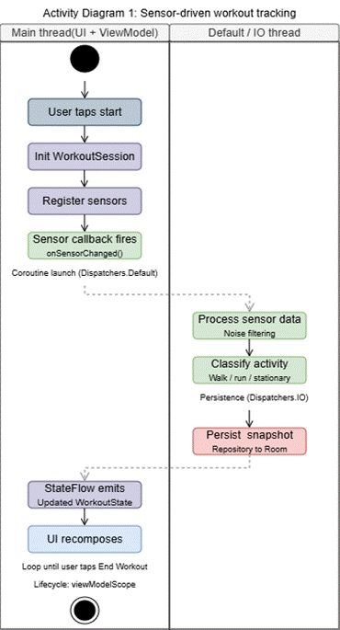

Activity Diagram 2: AI Insights Generation

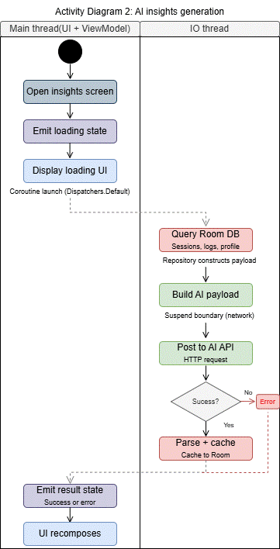

Activity Diagram 3: Manual Health Data Logging
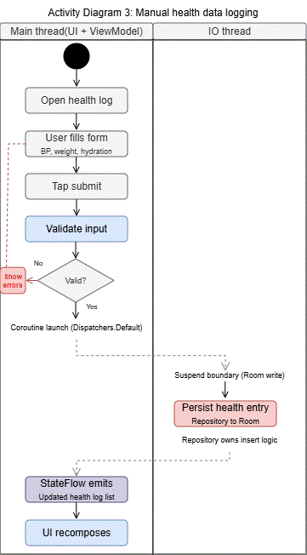

Sequence Diagrams
The following sequence diagrams model how work moves through the system, where suspend boundaries occur, which layer owns which responsibility, and how state returns to the UI reactively.
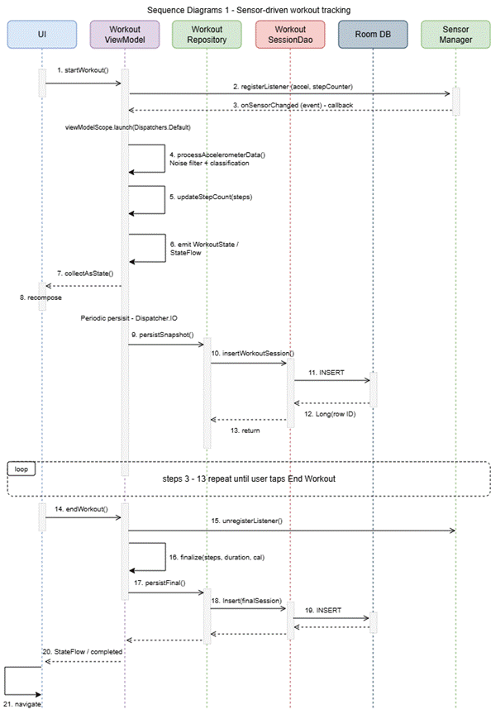
Coroutine Ownership: All coroutines launched in viewModelScope (WorkoutViewModel). Cancellation on ViewModel.onCleared().
Suspend Boundaries: Steps 10-15 (periodic persist) and Steps 20-21 (final persist) execute on Dispatchers.IO.
Sensor Callback: Step 3 fires on Main Thread; immediately transitions to coroutine in Step 4.
State Mutation: Steps 5-7: sensor data is processed and emitted as domain state.
Observable Effect: Step 8: UI recomposes from StateFlow.
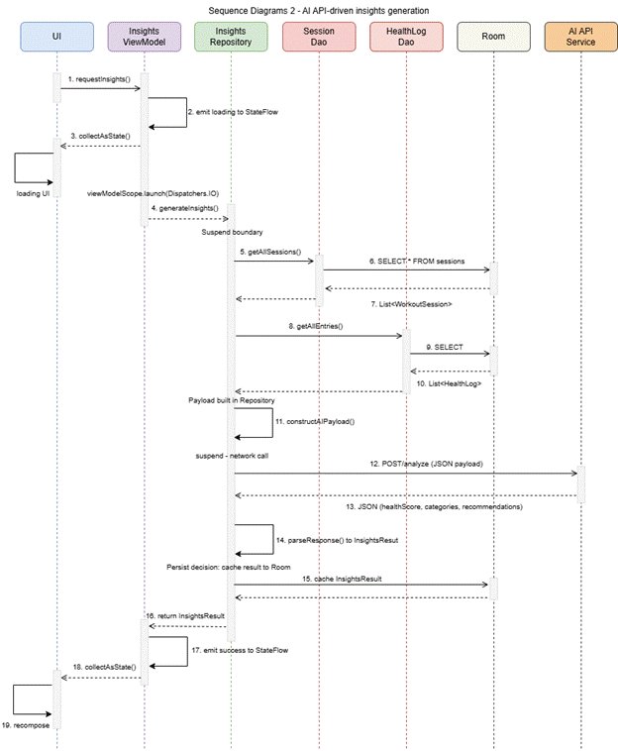

Persisted Fields: healthScore, categoryScores, recommendations, timestamp (cached for offline access).
Transient Fields: loading state, error state (UI-only, not persisted).
Coroutine Ownership: viewModelScope in InsightsViewModel. Navigation away cancels the API call.
Suspend Boundaries: Steps 5-17 (entire repository chain runs on Dispatchers.IO). Steps 6-8, 9-11 (Room queries), Step 13-14 (HTTP call).
Response Mapping: Step 15: Raw JSON mapped to InsightsResult domain model.
Flow Emission: Steps 17-19: Result flows back through ViewModel StateFlow to UI.

State Machine Diagram
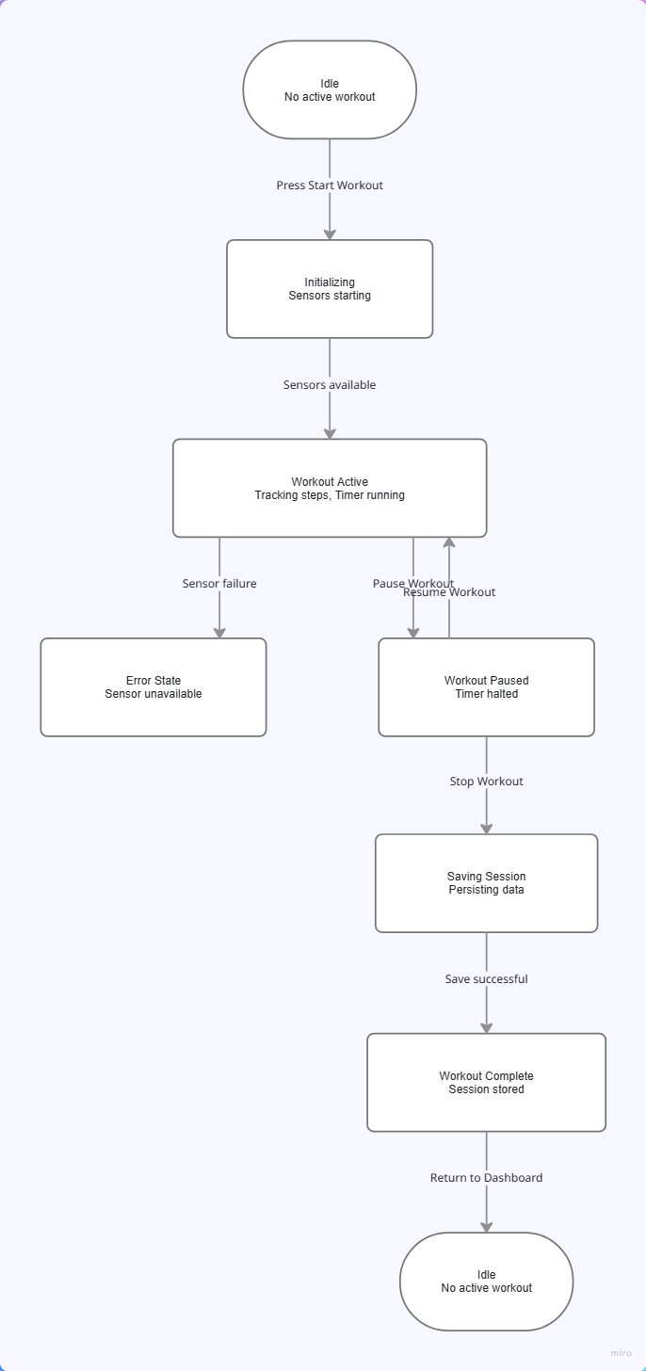

Main Behavioral Core Reasoning:
This state machine represents the behavioral core of the system because workout tracking is the primary real-time feature that drives the application’s sensor processing, reactive UI updates, persistence, and AI analysis. The system continuously transitions between states such as idle, active tracking, paused, saving, and completed based on user actions and sensor events. These state changes control how data flows through the ViewModel, StateFlow, and Room persistence layers, making workout session management the central behavior that connects the application’s architecture and functionality.

